When using Hibernate we can use

Query

Hibernate allow to return Typed query using

A constructor in the used class with expected the exact argument called in query example

And the “NEW” arg in the query example:



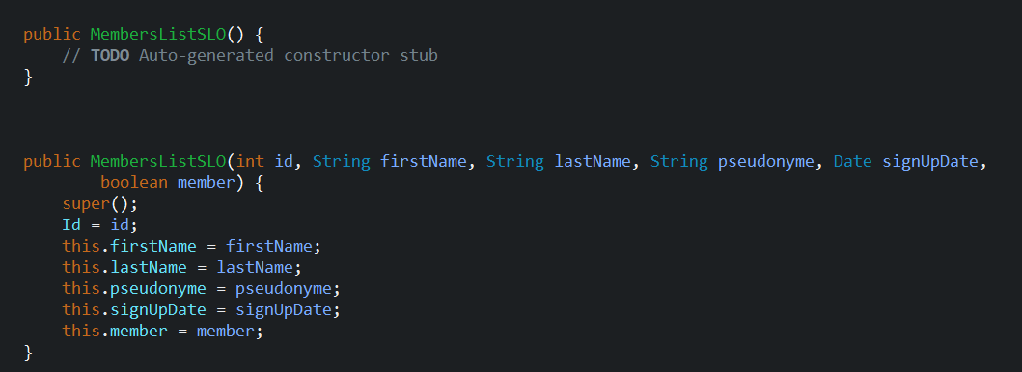

So here we have to constructor and the new instance in query

The main inconvenient on that is we have different type, string, Date, Boolean , but from DB we received data with not the final format we want and so we need to parse all this data

For example, Date is received as yyyy-mm-dd HH:mm:SS:m and we want this pattern “dd MMMM yyyy” so in dao we need to parse this date to the time format wished

Idem concerning Boolean we do not want the Boolean value but a specific string corresponding to true or false so again need parsing in dao

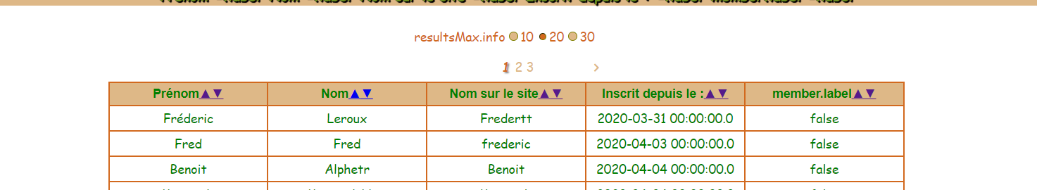

As we want to centralize the more possible information we have created several annotations like @DateRawFormat, @ToTranslate to use on entity class associated with simple named query and list parser by this way we can retrieve a list of class od interest containing the exact data we want

See dao list generic for more information

Example

entity

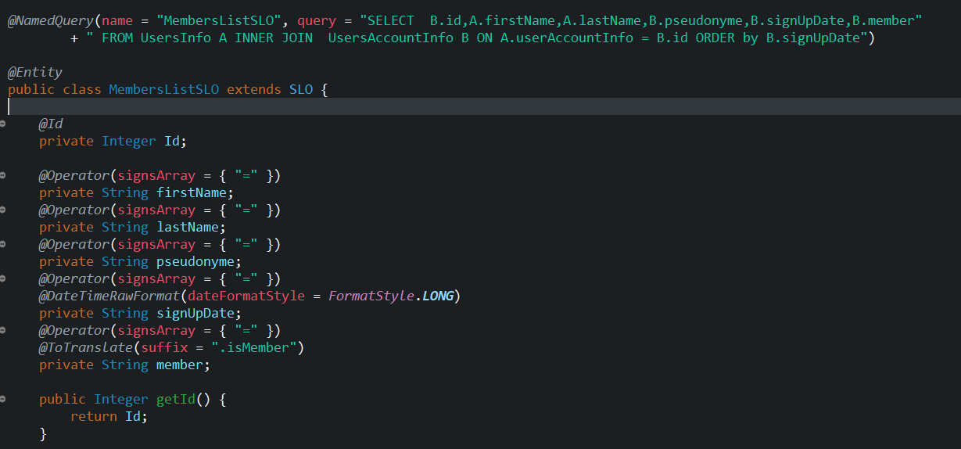

Dao

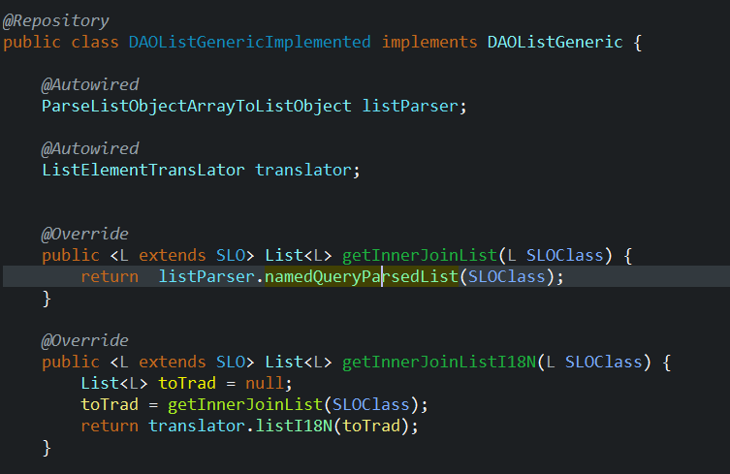

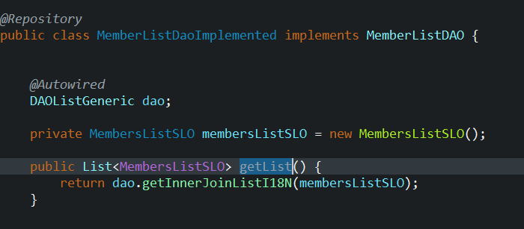

Gives

